# Normal Distribution

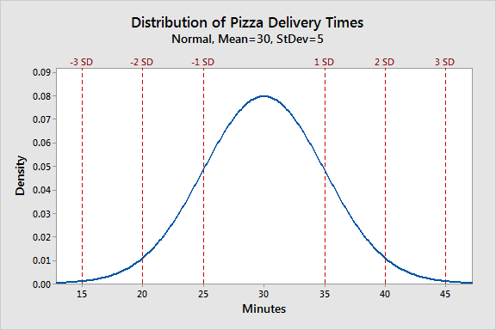

**Properties of the Normal Distribution:**

**Symmetry**: The normal distribution is perfectly symmetrical around its mean. This means that the mean, median, and mode are all equal and located at the center of the distribution.

**68-95-99.7 Rule**: The empirical rule, also known as the 68-95-99.7 rule, states that approximately 68% of the data falls within one standard deviation of the mean, about 95% falls within two standard deviations, and nearly 99.7% falls within three standard deviations.

**Central Limit Theorem**: The central limit theorem is a fundamental property of the normal distribution. It states that the distribution of the sample means (or sums) of sufficiently large random samples from any population will be approximately normally distributed, regardless of the population's underlying distribution.

**Infinite Tails**: The normal distribution has infinite tails, meaning that it extends infinitely in both directions from the mean. In practice, this means there is a small but nonzero probability of observing extremely rare events.

**Parameterization**: The normal distribution is characterized by two parameters: the mean (μ) and the standard deviation (σ). These parameters determine the center and spread of the distribution, respectively.

**Impact of Outliers on the Normal Distribution:**

**Skewness**: Outliers can introduce skewness to the distribution. If you have one or more extreme values on one side of the distribution, it can become positively or negatively skewed, disrupting the symmetry of the normal distribution.

**Central Tendency**: Outliers can have a substantial impact on the mean. A single extreme outlier can pull the mean in its direction, making it an unreliable measure of central tendency. The median, being less sensitive to outliers, may provide a better representation of the center.

**Dispersion**: Outliers can inflate the standard deviation and other measures of dispersion. This happens because the standard deviation accounts for the variability of all data points, including outliers.

**Explain how to standardize data using Z-scores:**

Standardizing data using Z-scores is a common technique in statistics and data analysis to transform variables into a standard scale with a mean of 0 and a standard deviation of 1. This process allows for easier comparison and interpretation of data across different variables and datasets. Here's how to standardize data using Z-scores:

Steps to Standardize Data using Z-Scores:

1. Calculate the Mean (μ) and Standard Deviation (σ) of the variable you want to standardize. These are the population parameters for the variable.

2. For each data point (x) in the dataset, use the formula for Z-score:

Z= x−μ/σ

x is the individual data point.

μ is the mean of the variable.

σ is the standard deviation of the variable.

3. Calculate the Z-score for each data point using the formula from step 2. The resulting values represent how many standard deviations each data point is from the mean. Positive Z-scores indicate values above the mean, while negative Z-scores indicate values below the mean.

4. The standardized dataset now consists of these Z-scores. It will have a mean (average) of 0 and a standard deviation of 1.

**What is the purpose of standardization:**

Comparison: It allows for meaningful comparisons between variables with different units and scales. For example, you can compare the performance of students in different subjects or compare variables with different measurement units (e.g., height in inches and weight in pounds).

Data Transformation: Standardization transforms data into a format suitable for certain statistical analyses, such as principal component analysis (PCA) and some machine learning algorithms, where the scale of variables can affect the results.

Outlier Detection: Standardization can make outliers more apparent. Outliers are often defined as data points with Z-scores above a certain threshold (e.g., |Z| > 3), where |Z| represents the absolute value of the Z-score.

Interpretability: When variables are standardized, the Z-scores represent the number of standard deviations a data point is from the mean. This provides a clear and interpretable way to understand the relative position of each data point within the distribution.

**How does standardization relate to the normal distribution?**

Z-Scores and Normal Distribution: When data is standardized using Z-scores, it transforms the original distribution into a new distribution with a mean of 0 and a standard deviation of 1. This standardized distribution closely resembles a standard normal distribution, which is a special case of the normal distribution with a mean (μ) of 0 and a standard deviation (σ) of 1. The Z-scores of data points represent how they would fit within a standard normal distribution.

Normality Testing: Standardization is often used as a preliminary step in testing for normality. After standardizing the data, you can visually compare it to a standard normal distribution or use statistical tests like the Anderson-Darling test or the Shapiro-Wilk test to assess whether the standardized data follows a normal distribution.

By standardizing data using Z-scores, you make it easier to work with and analyze, especially when dealing with data from different sources or with different units of measurement. It simplifies the interpretation of data and is a fundamental technique in statistics and data preprocessing.

# Kurtosis

Kurtosis is a statistical measure that describes the shape of the probability distribution of a random variable. It quantifies the "tailedness" or the degree of heaviness of the tails of the distribution compared to a normal distribution.

There are three common types of kurtosis:

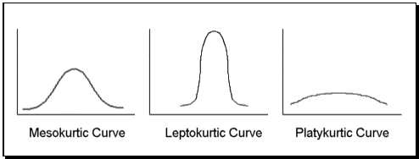

Mesokurtic (Normal Kurtosis): A distribution with kurtosis equal to zero is called mesokurtic. This means that the tails of the distribution have the same heaviness as a normal distribution. The standard normal distribution has zero kurtosis.

Leptokurtic: A distribution with positive kurtosis (greater than zero) is called leptokurtic. This indicates that the distribution has heavier tails and a sharper peak in the center compared to a normal distribution. Leptokurtic distributions have more extreme values and tend to have a more concentrated central peak.

Platykurtic: A distribution with negative kurtosis (less than zero) is called platykurtic. This implies that the tails of the distribution are lighter than those of a normal distribution, and the central peak is flatter and more spread out. Platykurtic distributions have fewer extreme values than a normal distribution.

Kurtosis is often used in statistics to assess the shape of data distributions, especially in fields like finance and risk analysis. It provides additional information about the distribution beyond measures like mean and standard deviation. However, it's important to note that kurtosis is a dimensionless measure and should be interpreted in conjunction with other statistical properties of the data to gain a complete understanding of the distribution's characteristics.